COVID-19 DATA ANALYSIS
Data Analysis Using Microsoft Excel, PivotTables, PivotCharts and Dashboard

Project Report
Prepared using the supplied COVID-19 dataset
Analysis period: 2020–2025

Submitted by
Farhana Sultana, Rabin Das & Sanju Jana

Abstract

This project presents an Excel-based analysis of COVID-19 data for Indian States and Union Territories covering the period from 2020 to 2025. The supplied dataset contains 198 records and eight analytical fields: Year, State/UT, New COVID Cases, Deaths, Recovered Cases, Active Cases at Year End, Recovery Rate %, and Case Fatality Rate %. The purpose of the project is to convert the raw dataset into meaningful information through data cleaning, aggregation, PivotTables, PivotCharts, dashboard design, and forecasting.
The analysis shows strong variation in the recorded values across years. In the supplied dataset, 2021 has the highest total number of new COVID-19 cases at 34,265,213 and also the highest recorded deaths at 2,071,089. The highest total recovered cases occur in 2022, with 4,043,534 recoveries. The active-case total is also highest in 2021 at 30,350,527. From 2023 onward, the recorded values decline substantially, reaching 6,495 new cases and zero recorded deaths in 2025.
The dashboard combines year-wise and state-wise views, including a year-wise new-case chart, state-wise recovery rate chart, case-fatality-rate chart, year-wise recovery-rate chart, death-count chart, and a pie chart showing the relative contribution of new cases, active cases, recovered cases, and deaths. A forecasting model included in the workbook extends the new-case trend into 2026 and 2027. The forecast shown in the dashboard estimates about 325 cases for 2026 and 30 cases for 2027, with confidence ranges of approximately 163–488 and 15–45 respectively.
The project demonstrates how spreadsheet-based analytics can transform a structured dataset into a visual decision-support tool. At the same time, the results should be interpreted as an analysis of the supplied dataset rather than as independently verified public-health statistics, because some values and calculated rates show unusual patterns.

Introduction

COVID-19 was a major global health emergency that affected public health, education, employment, businesses, transportation, travel, and everyday life. The rapid spread of the virus created large volumes of data containing information about infections, deaths, recoveries, and active cases. Organizing and analyzing such information is important because raw numbers alone are difficult to interpret. Data analysis helps identify patterns, compare regions, and understand how the situation changed over time.
This project focuses on an Excel-based approach to COVID-19 data analysis. The dataset supplied for the project contains yearly observations for Indian States and Union Territories from 2020 to 2025. Instead of examining each row separately, the project summarizes the data using PivotTables and presents the results through PivotCharts and a consolidated dashboard.
The project follows a practical data-analysis workflow. First, the dataset is inspected and organized. Next, summary calculations are created using PivotTables. These summaries are then converted into charts so that trends and comparisons can be understood visually. Finally, the charts and filters are arranged into a dashboard that provides a single view of the most important information.
The project also includes a forecasting component. Forecasting uses the historical trend in the dataset to estimate possible future new-case values. Such forecasts are not guarantees; they are model-based estimates that depend heavily on the quality, completeness, and consistency of the historical data.
Overall, the project demonstrates the use of Microsoft Excel as a basic business-intelligence and data-visualization tool.

Objectives of the Project

- To analyze COVID-19 cases across different States and Union Territories.
- To compare deaths, recovered cases, and active cases during the study period.
- To examine changes in recovery rate and case fatality rate across years and states.
- To summarize the dataset using Excel PivotTables for easier interpretation.
- To create PivotCharts that visually represent important COVID-19 trends and comparisons.
- To design an informative dashboard that combines multiple views of the dataset in one place.
- To use the available historical data to prepare a simple forecasting model for future new cases.
- To identify major patterns and insights that can be communicated clearly through charts and tables.

Scope of the Project
The scope of the project is limited to the variables available in the supplied workbook. The analysis covers the years 2020–2025 and focuses on cases, deaths, recoveries, active cases, recovery rate, and case fatality rate. The project does not attempt to explain medical causes or establish causal relationships. Its primary purpose is to demonstrate data organization, summarization, visualization, and basic forecasting in Excel.

Expected Outcome
The expected outcome is a clear Excel dashboard supported by PivotTables and PivotCharts, together with a written interpretation of the major patterns observed in the dataset. The report documents the complete workflow so that another student can understand how the raw data was converted into the final analytical presentation.

Dataset Description

The records cover six years, from 2020 to 2025, and include observations for States and Union Territories.

Field | Data Type | Description
Year | 2020 - 2025 | Year of the recorded observation.
State/UT | West Bengal | Name of the Indian State or Union Territory.
New COVID Cases | 26,71,381 | Number of new COVID-19 cases recorded for the State/UT and year.
Deaths | 6,94,485 | Number of deaths recorded for the State/UT and year.
Recovered Cases | 3,57,436 | Number of recovered cases recorded for the State/UT and year.
Active Cases at Year End | 16,19,460 | Number of active cases remaining at the end of the year.
Recovery Rate % | 57.16167 % | Recovery-rate value provided in the dataset.
Case Fatality Rate % | 7.373333 % | Case-fatality-rate value provided in the dataset.

Dataset Coverage
Year | States/UTs | New Cases | Deaths | Recovered | Active at Year End
2020 | 36 | 10,292,112 | 4,679,041 | 0 | 5,613,071
2021 | 36 | 34,265,213 | 2,071,089 | 1,843,597 | 30,350,527
2022 | 36 | 9,840,804 | 71,480 | 4,043,534 | 5,725,790
2023 | 36 | 333,257 | 2,342 | 289,543 | 41,372
2024 | 36 | 13,842 | 6 | 13,515 | 321
2025 | 36 | 6,495 | 0 | 6,495 | 0

Data Analysis Using PivotTables

Year-wise New Cases
The PivotTable groups the data by Year and summarizes New COVID Cases, making it possible to compare the size of reported case totals over time.
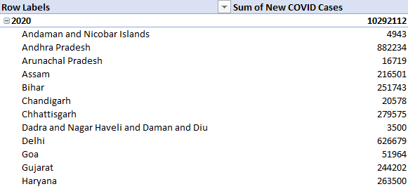

Year-wise Deaths
The deaths field is summarized by year to identify the period with the highest recorded death count and the subsequent decline.
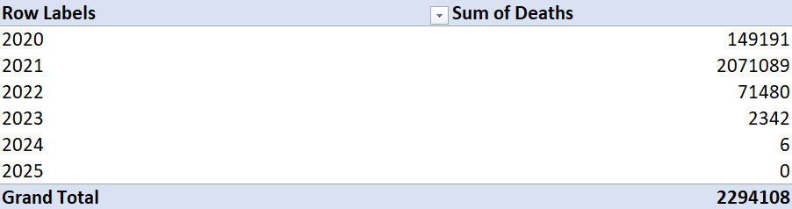

Year-wise Recovery Rate
The Recovery Rate % field is grouped by year to show how the supplied recovery-rate values change across the study period.
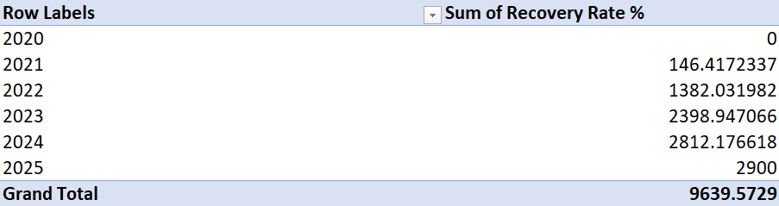
State-wise Analysis

Top States/UTs by New COVID Cases
State/UT | Total New Cases (2020–2025)
Maharashtra | 10,190,569
Kerala | 7,670,220
Karnataka | 5,002,787
Tamil Nadu | 4,459,633
Uttar Pradesh | 2,732,074
West Bengal | 2,671,381
Delhi | 2,664,023
Andhra Pradesh | 2,587,635
Odisha | 1,677,558
Rajasthan | 1,636,513

Top States/UTs by Deaths
State/UT | Total Deaths (2020–2025)
Maharashtra | 968,909
Karnataka | 828,482
West Bengal | 804,732
Chhattisgarh | 549,610
Delhi | 537,910
Uttar Pradesh | 514,406
Andhra Pradesh | 502,337
Kerala | 344,547
Tamil Nadu | 206,284
Bihar | 186,858

Pivot-Charts and Visual Analysis

COVID Data Year Wise
This chart shows the year-wise distribution of new COVID-19 cases across different States and Union Territories.
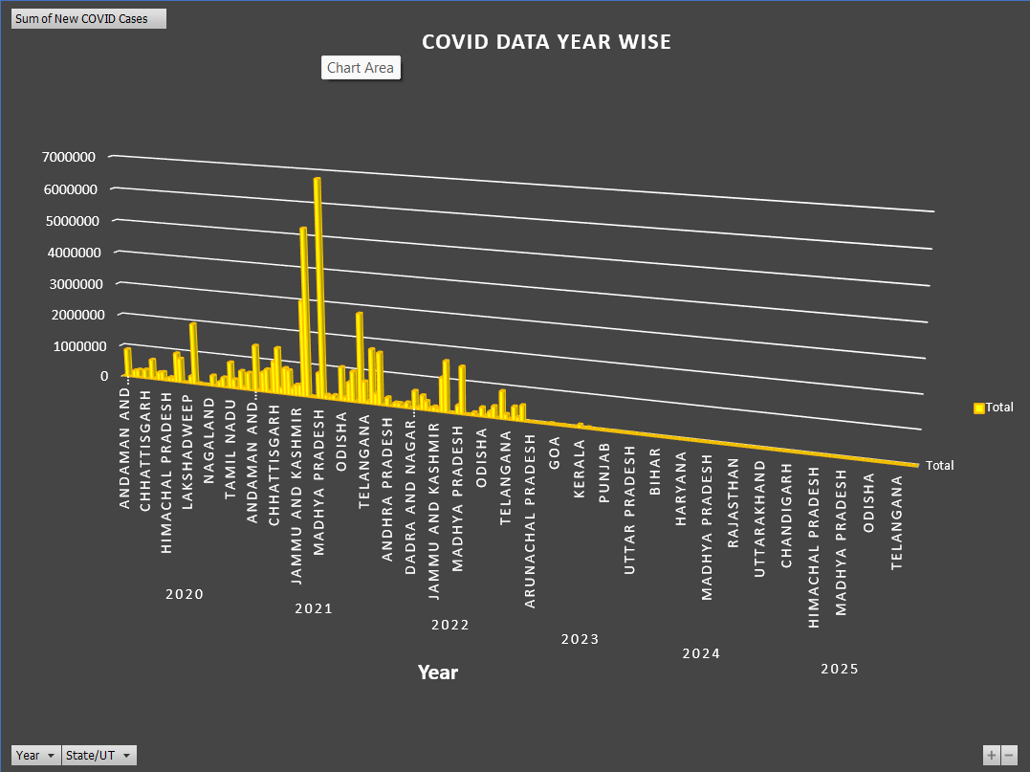

Year-wise Recovery Rate
This chart shows the change in the supplied recovery-rate values from 2020 to 2025.
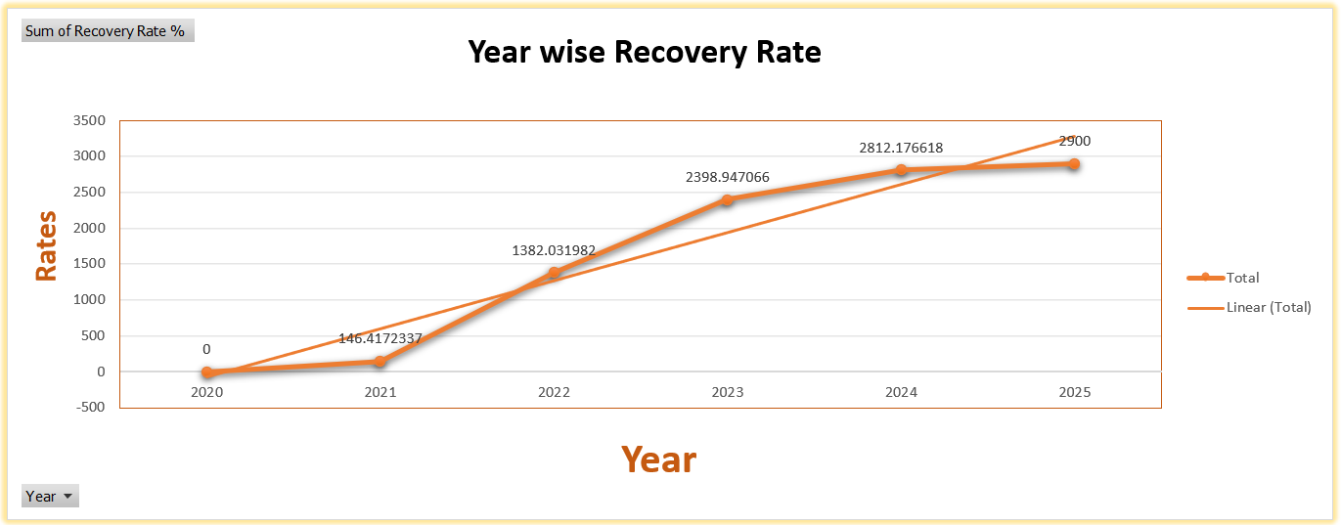

Year-wise COVID Pie Chart
This chart shows the relative distribution of new cases, active cases, recovered cases, and deaths in the selected year-wise summary.
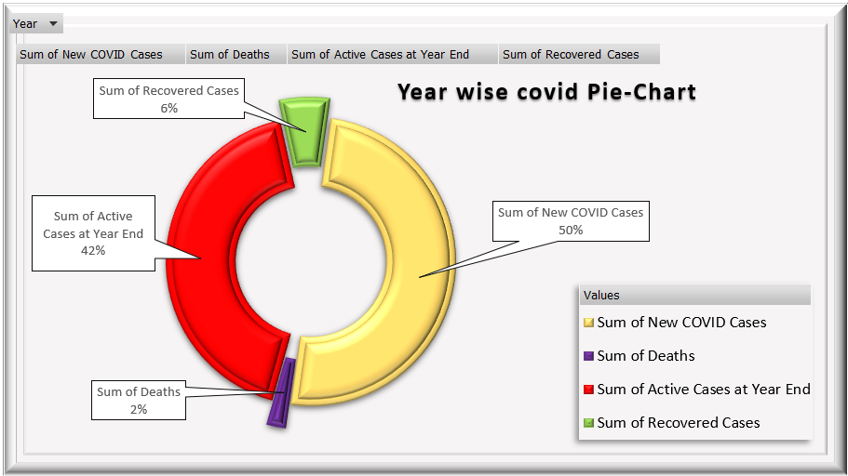

Statewise Recovery Rate
This chart compares the supplied recovery-rate values across different States and Union Territories.
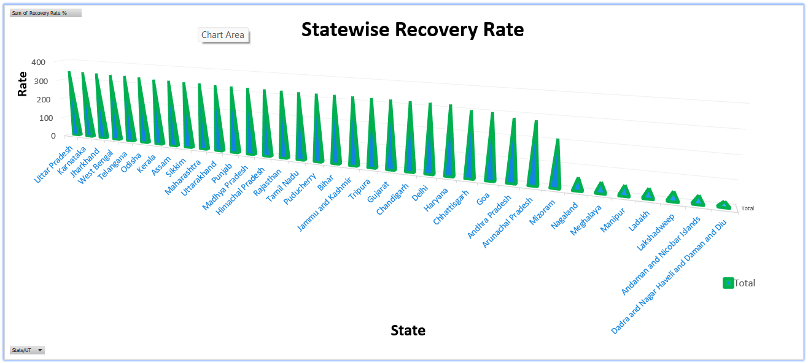

Case Fatality Rate
This chart shows the change in the supplied case-fatality-rate values from 2020 to 2025.
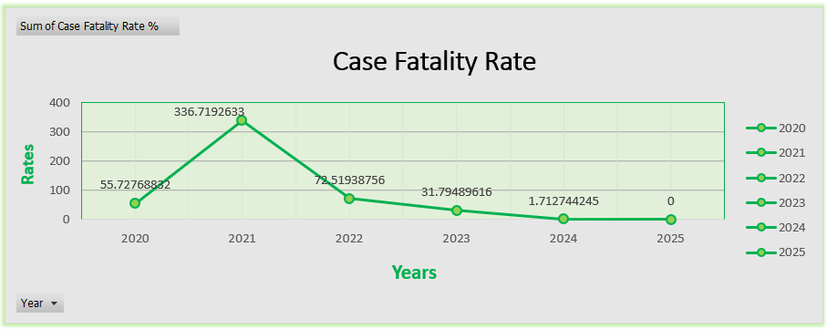

Death Counts
This chart shows that the recorded death count peaks in 2021 and then falls sharply in the following years.
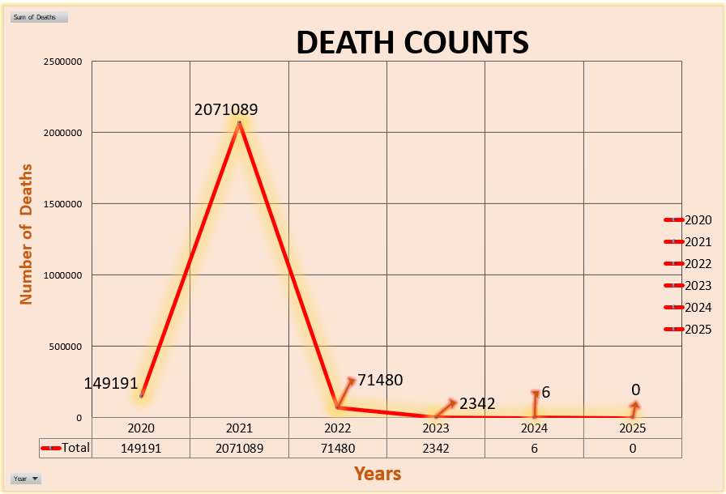

Dashboard Development

Main Dashboard Components
- Year-wise new COVID case visualization for comparing reported cases across States/UTs and years.
- State-wise recovery-rate visualization for comparing recovery-related values across regions.
- Case fatality rate chart showing the year-wise change in the supplied fatality-rate values.
- Year-wise recovery-rate chart showing the overall direction of the supplied recovery-rate measure.
- Death-count chart highlighting the major peak in 2021 and the subsequent decline.
- Doughnut/pie visualization showing the relative share of new cases, active cases, recovered cases, and deaths.
- Slicers or PivotChart filters that allow the user to select years or States/UTs where applicable.

Dashboard Design Approach
The dashboard uses contrasting chart areas and clear headings so that each visualization has a distinct purpose. The charts are positioned together to reduce the need to switch between worksheets. Filters provide interactivity, while PivotCharts ensure that the visualizations respond to changes in the underlying PivotTable selections.
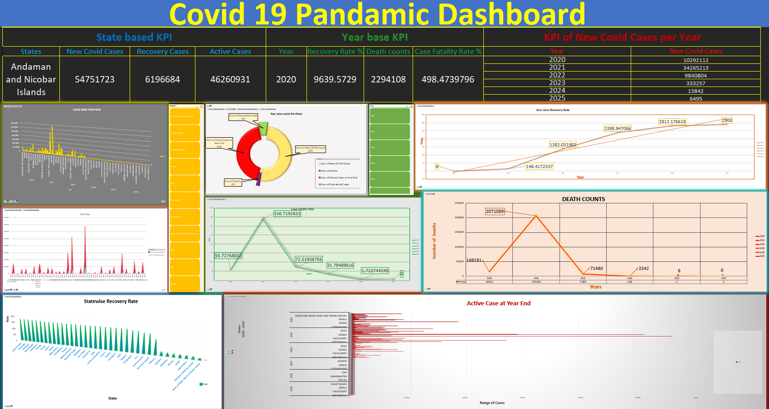
Forecasting Model

Forecast Values Used in the Dashboard
Year | Forecast New Cases | Lower Confidence Bound | Upper Confidence Bound
2026 | 325 | 163 | 488
2027 | 30 | 15 | 45
The forecasting chart shows the historical values from 2020–2025 together with forecast values for 2026–2027. The forecast line continues the strong downward trend observed in the later years of the dataset. The confidence bounds provide a range around the forecast rather than a single guaranteed value.
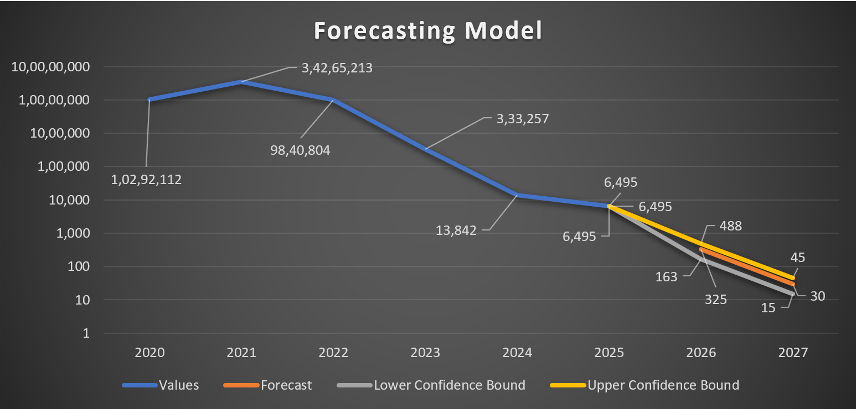
Conclusion

Conclusion
This project successfully demonstrates the use of Microsoft Excel for COVID-19 data analysis. The supplied dataset was organized and summarized using PivotTables, converted into PivotCharts, and combined into an interactive dashboard. The analysis identifies 2021 as the peak year for new cases, deaths, and active cases in the workbook, while 2022 has the highest recorded recovery total. The later years show a substantial decline in the recorded values. The forecasting component extends this downward trend into 2026 and 2027, although the estimates should be treated cautiously.

References / Data Source
Primary project data source: COVID Dataset(1).xlsx supplied for this assignment. The report analysis is based on the Data sheet and the forecasting/dashboard worksheets contained in the workbook.
Software used: Microsoft Excel for data organization, PivotTables, PivotCharts, dashboard development, and forecasting.

